Union Find (Disjoint Set Union, DSU)

1) Definition
Disjoint Set Union (DSU) is a data structure used to efficiently manage a collection of elements partitioned into non-overlapping (disjoint) sets.
It supports fast operations to:
- Determine whether two elements belong to the same set (connectivity)
- Merge two sets into one (union)

2) Core Operations
Operation | Meaning | Time Complexity*
find(x) | Returns the representative (root) of the set containing x | ~ O(1) amortized
union(x, y) | Merges the sets containing x and y | ~ O(1) amortized
* With path compression + union by rank/size

3) Why DSU is Useful
- Extremely effective for connectivity problems
- Supports dynamic grouping
- Avoids repeated DFS/BFS for connectivity queries
- Handles large graphs efficiently

4) Benefits
- Near constant amortized time per operation
- Ideal for incrementally building components
- Efficient cycle detection in undirected graphs
- Compact and simple implementation

5) When to Use DSU (Recognition Guide)
Look for keywords such as:
- union / merge / connect
- components / groups
- same group / friend circle
- dynamic connectivity
- redundant edge
- cycle detection
- minimum spanning tree (MST)
- edges added over time
- grid connectivity problems
Typical pattern:
Start with all elements separate → merge when needed
DSU is especially powerful for graphs, MST, and grid problems.

6) Common Applications
- Detecting cycles in undirected graphs
- Counting connected components
- Kruskal’s algorithm (Minimum Spanning Tree)
- Network connectivity problems
- Friend circles / groups
- Dynamic island problems
- Redundant connection detection

7) Popular LeetCode Problems Using DSU
Examples:
- 200 — Number of Islands
- 261 — Graph Valid Tree
- 547 — Number of Provinces
- 684 — Redundant Connection
- 685 — Redundant Connection II
- 721 — Accounts Merge
- 765 — Couples Holding Hands
- 778 — Swim in Rising Water
- 839 — Similar String Groups
- 924 — Minimize Malware Spread
- 947 — Most Stones Removed
- 1319 — Number of Operations to Make Network Connected
- 1579 — Remove Max Number of Edges
- 1168 — Optimize Water Distribution
- 990 — Satisfiability of Equality Equations

8) Standard DSU Workflow
- Initialize DSU for n elements
→ each element is its own parent
- For every relation / edge:
  - Check connectivity using find
  - Merge sets using union if needed
- Optional operations:
  - Detect cycle
  - Count unique roots (number of components)
- Return result based on problem requirements

9) Detecting a Valid Tree Using DSU
A graph is a valid tree if:
- It has no cycles
- It is fully connected
Procedure:
For each edge (u, v):
- If find(u) == find(v) → cycle detected → not a tree
- Else → union(u, v)
After processing all edges:
- If number of components = 1 → valid tree

Disjoint Set Union (Union Find) — Visual Guide
🔹 Initial State (All Elements Separate)
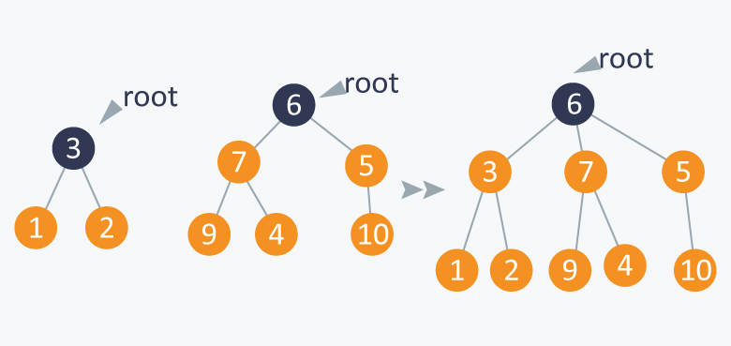
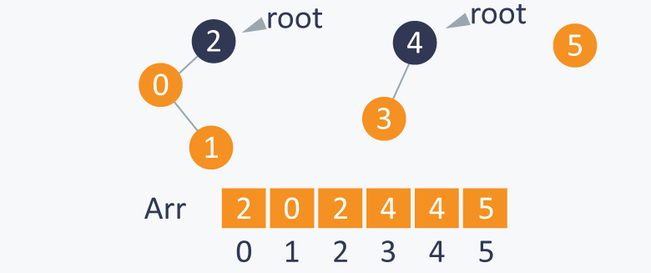
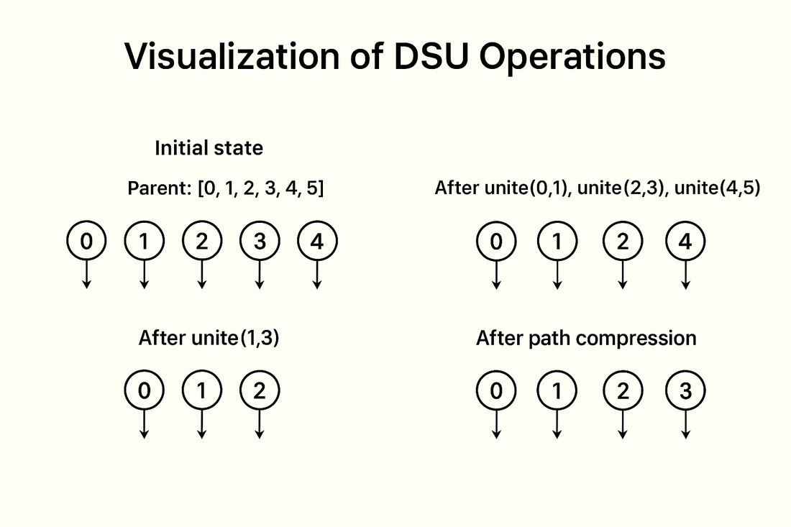
4
Each element is its own set (own parent).
Example:
{1}, {2}, {3}, {4}, {5}

🔹 After Union Operations (Sets Merge)
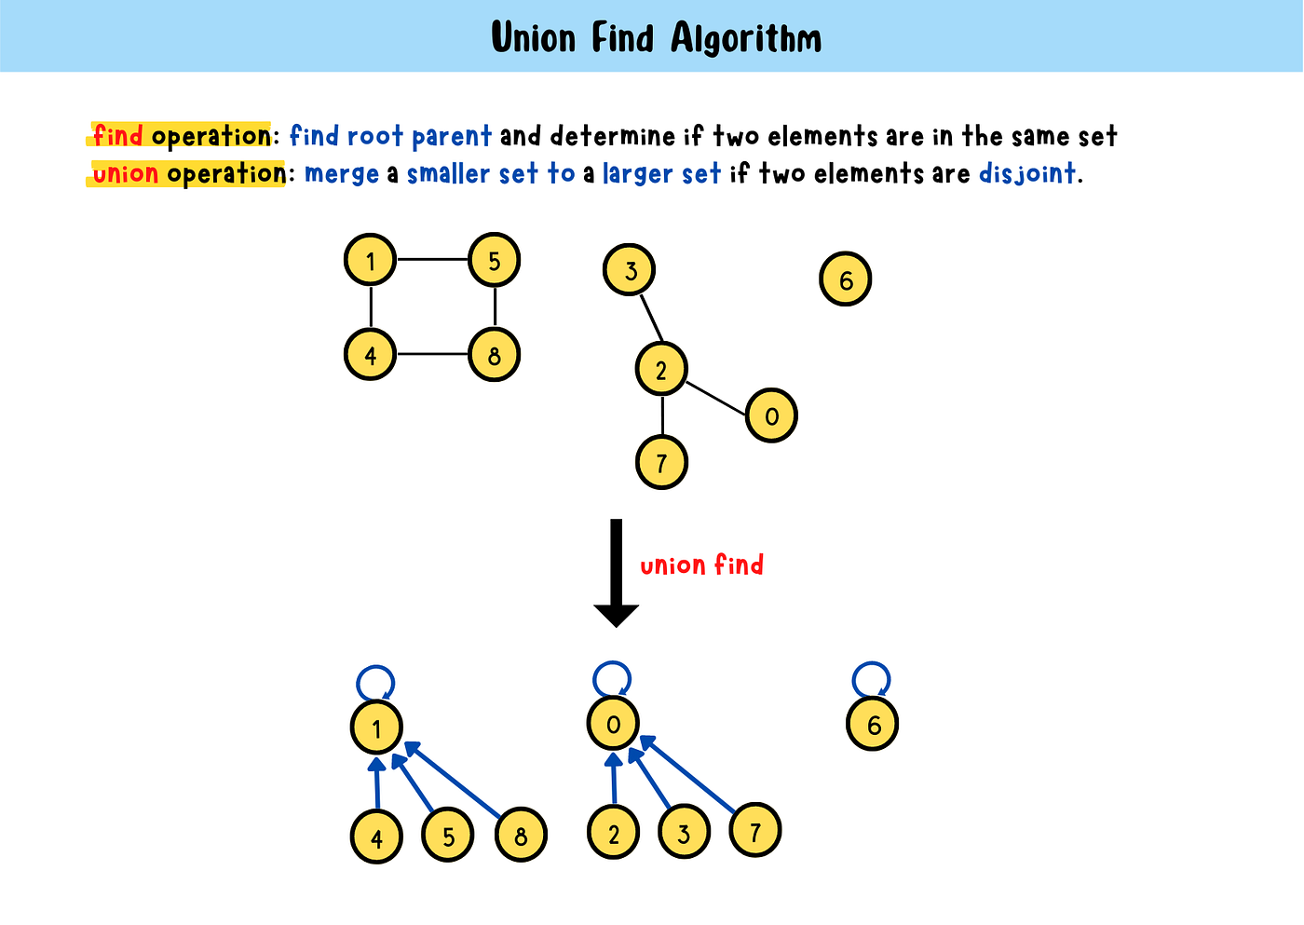
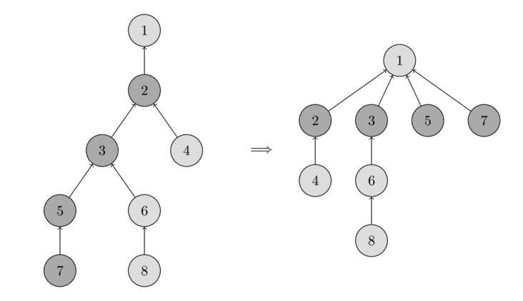
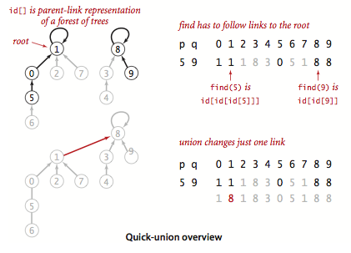
4
Union connects components into larger groups.
Example after unions:
{1,2,3} and {4,5}

🔹 Find Operation (Root / Representative)
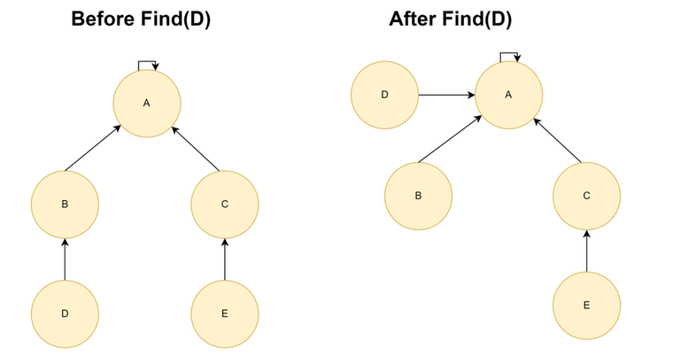
4
find(x) returns the root that represents the set.
All nodes in the same set share the same root.

🔹 Path Compression Optimization
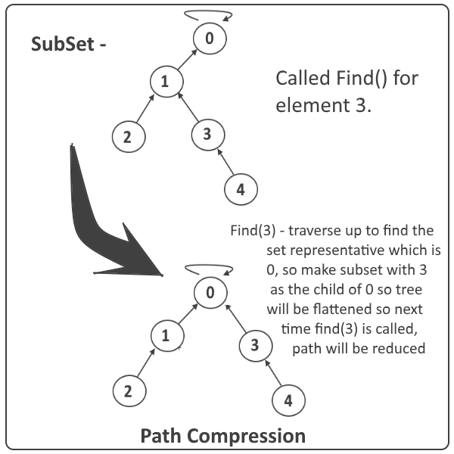
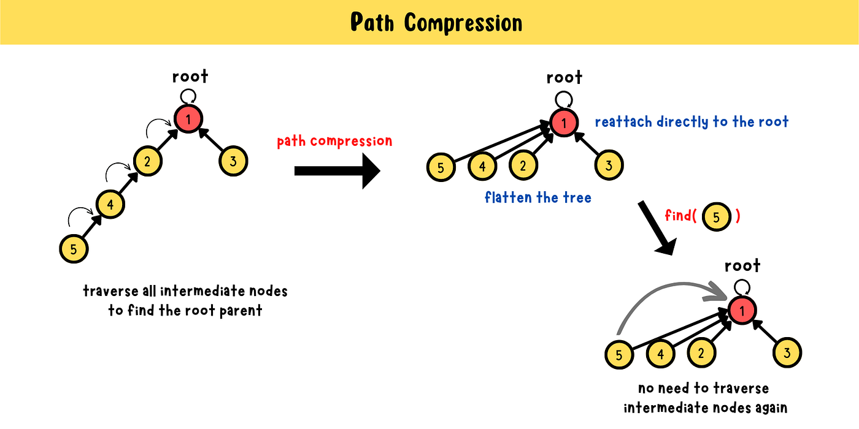
4
After a find operation, nodes point directly to the root → tree becomes flat → future operations become very fast.

DSU Problems — Easy → Hard (LeetCode)
🟢 Easy
Basic connectivity / grouping.
- 1971 — Find if Path Exists in Graph
- 1791 — Find Center of Star Graph
- 323 — Number of Connected Components in Undirected Graph
- 261 — Graph Valid Tree (basic version)
Focus: detect connectivity, components.

🟡 Medium
Core DSU interview level.
- 547 — Number of Provinces
- 684 — Redundant Connection
- 1319 — Number of Operations to Make Network Connected
- 721 — Accounts Merge
- 947 — Most Stones Removed with Same Row or Column
- 990 — Satisfiability of Equality Equations
- 1061 — Lexicographically Smallest Equivalent String
- 1202 — Smallest String With Swaps
- 200 — Number of Islands (DSU approach)
- 305 — Number of Islands II (dynamic DSU)
Focus: dynamic unions, grouping by properties.

🔴 Hard
Advanced DSU + Graph / Greedy / MST / Offline Queries.
- 765 — Couples Holding Hands
- 778 — Swim in Rising Water (DSU + sorting)
- 1579 — Remove Max Number of Edges to Keep Graph Fully Traversable
- 685 — Redundant Connection II (directed graph)
- 924 — Minimize Malware Spread
- 928 — Minimize Malware Spread II
- 1697 — Checking Existence of Edge Length Limited Paths
- 1722 — Minimize Hamming Distance After Swap Operations
- 1168 — Optimize Water Distribution in a Village (MST + DSU)
Focus: DSU combined with other techniques.

🧠 Quick Recognition Rule
Use DSU when:
- You need to dynamically merge groups
- You only care about connectivity, not paths
- Edges are added over time
- You must detect cycles in an undirected graph
- Problem mentions components / groups / unions

🔷 Weighted DSU (Union Find with Weights)
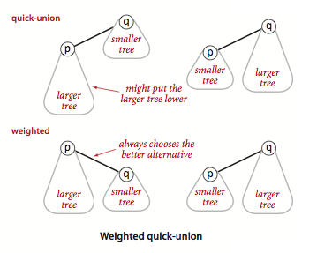
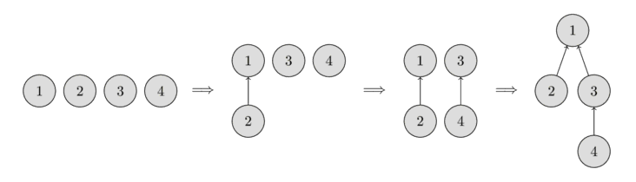
4
✅ Idea
Each node stores extra information relative to its parent, such as:
- Distance
- Difference
- Ratio
- Potential value
This allows DSU to answer queries like:
What is the relationship between x and y?

✅ When to Use
Problems involving constraints between elements:
- x − y = k
- x / y = k
- Distance between nodes
- Relative position or weight

✅ Key Concept
Store:
parent[x] → parent of x
weight[x] → relation from x to parent[x]
After path compression, weight becomes relation to the root.

✅ Classic Problem
- 399 — Evaluate Division
(Maintain ratios between variables)

✅ Java Template (Ratio Type)
class WeightedDSU {
int[] parent;
double[] weight; // weight[x] = x / parent[x]
public WeightedDSU(int n) {
parent = new int[n];
weight = new double[n];
for (int i = 0; i < n; i++) {
parent[i] = i;
weight[i] = 1.0;
}
}
public int find(int x) {
if (parent[x] != x) {
int root = find(parent[x]);
weight[x] *= weight[parent[x]];
parent[x] = root;
}
return parent[x];
}
public void union(int x, int y, double value) {
int rx = find(x);
int ry = find(y);
if (rx != ry) {
parent[rx] = ry;
weight[rx] = weight[y] * value / weight[x];
}
}
public double query(int x, int y) {
if (find(x) != find(y)) return -1.0;
return weight[x] / weight[y];
}
}

🔷 Rollback DSU (Undo Union Find)
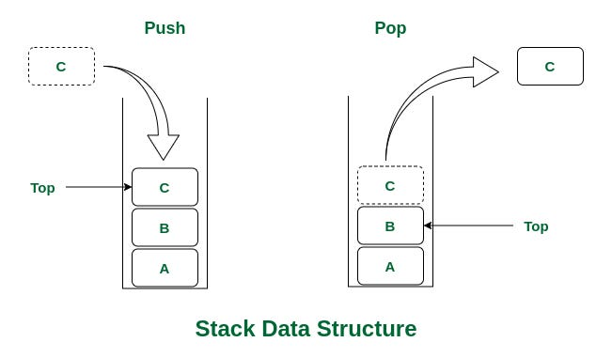
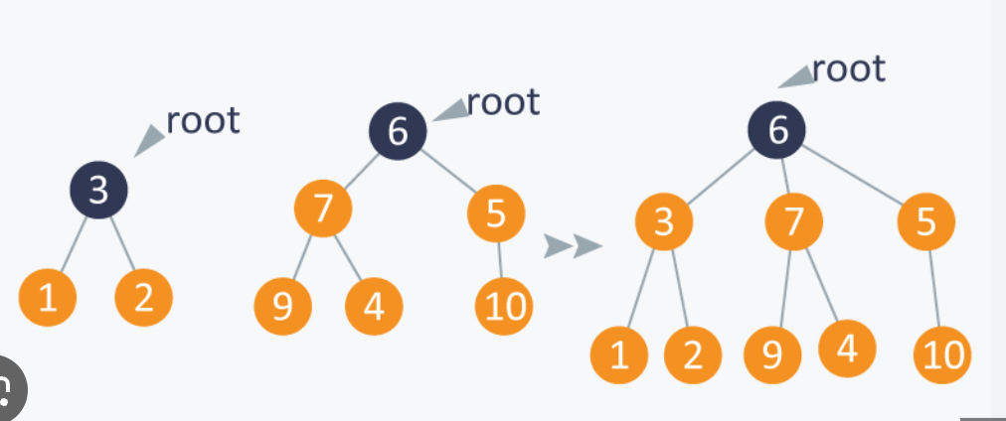
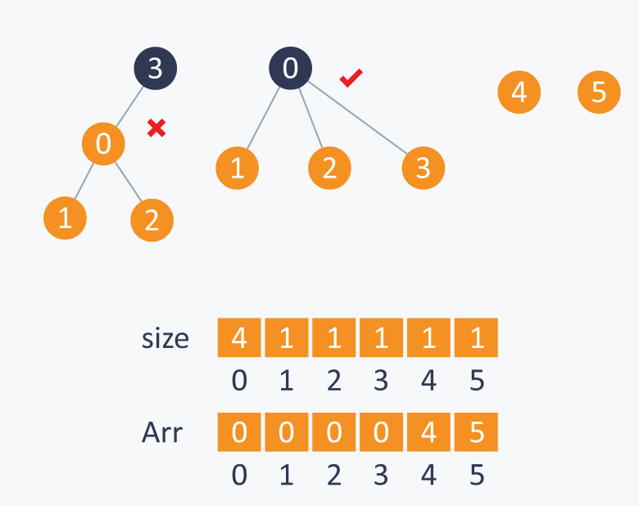
4
✅ Idea
Supports undoing previous union operations.
Useful when connectivity changes over time.

✅ Why Needed?
Standard DSU cannot remove edges.
Rollback DSU allows:
- Add edge
- Undo edge
- Query connectivity at different times

✅ Typical Use Cases
- Offline dynamic connectivity
- Divide and conquer on queries
- Backtracking algorithms
- Segment tree on time technique

✅ Important Notes
- Usually no path compression
- Use union by size/rank
- Store changes on a stack to undo later

✅ Java Template
class RollbackDSU {
int[] parent, size;
Stack<int[]> history;
public RollbackDSU(int n) {
parent = new int[n];
size = new int[n];
history = new Stack<>();
for (int i = 0; i < n; i++) {
parent[i] = i;
size[i] = 1;
}
}
public int find(int x) {
while (x != parent[x]) x = parent[x];
return x;
}
public void union(int a, int b) {
a = find(a);
b = find(b);
if (a == b) {
history.push(new int[]{-1, -1, -1});
return;
}
if (size[a] < size[b]) {
int t = a; a = b; b = t;
}
history.push(new int[]{b, parent[b], size[a]});
parent[b] = a;
size[a] += size[b];
}
public void rollback() {
int[] last = history.pop();
if (last[0] == -1) return;
int b = last[0];
parent[b] = last[1];
size[parent[b]] = last[2];
}
}

🔥 Weighted vs Rollback DSU — When to Use
Variant | Use Case
Weighted DSU | Maintain relationships (distance, ratio, constraints)
Rollback DSU | Undo operations / dynamic connectivity over time

🧠 Advanced Problems Using These
Weighted DSU
- 399 — Evaluate Division
- 990 — Equality Equations (difference variant)
- Problems with ratios or differences
Rollback DSU
- Dynamic connectivity queries
- Offline edge addition/removal problems
- Advanced competitive programming tasks

